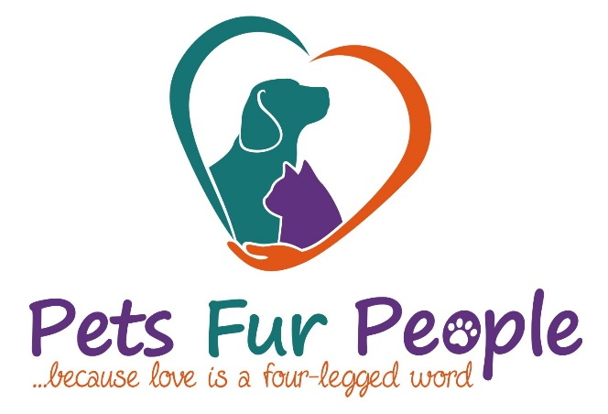

P.O. Box 6151 Tyler, Texas 75711 903 597-2471 fax 903 597-0708 501(c)3 www.petsfurpeople.org

Wish List

Dry ADULT DOG FOOD – Pedigree
Canned ADULT DOG FOOD -- Pedigree
Dry PUPPY CHOW -- Pedigree Puppy
MILK BONES - (NO Rawhide Chews)
CAT & KITTEN CHOW – dry Iams “Kitten”
CLAY CAT LITTER
POWDER LAUNDRY DETERGENT
DISHWASHING SOAP
BLEACH
BLANKETS
BATH TOWELS
DRYER SHEETS
PAPER TOWELS
DOG CHEW TOYS FOR STRONG CHEWERS
Kong toys – red or black
Nylabones

